

Practical Report

For IoT Practical



January 1, 2022

Darshan Ramjiyani (DSP)

DOCS, KSKV Kachchh University

* **4.5 Serial Communication – Receive Multiple text field from one message**
* **Arduino Code:**

int baudRate = 9600;

const int NUMBER_OF_FIELDS = 5;

int fieldIndex = 0;

int values[NUMBER_OF_FIELDS];

void setup()

{

  /* Established Serial Communication. */

  Serial.begin(baudRate);

  Serial.println("Connection Establishing connection...!");

  while(!Serial){}

  Serial.println("Connection Established!");

  /* Wait until Serial Communication not established. */

  while(!Serial){}

  /* Send data through Serial Communication. */

  Serial.println("- Name of Author : DSP -");

  Serial.println("---------------------------------------------------------");

}

void loop()

{

    if( Serial.available())

    {

        char ch = Serial.read();

        if(ch >= '0' && ch <= '9')

        {

            if(fieldIndex < NUMBER_OF_FIELDS)

                values[fieldIndex] = (values[fieldIndex] * 10) + (ch - '0');

        }

        else if (ch == ',')

            fieldIndex++;

        else

        {

            for(int i=0; i < min(NUMBER_OF_FIELDS, fieldIndex+1); i++)

            {

                Serial.println(values[i]);

                values[i] = 0;

            }

            fieldIndex = 0;

        }

    }

}

* 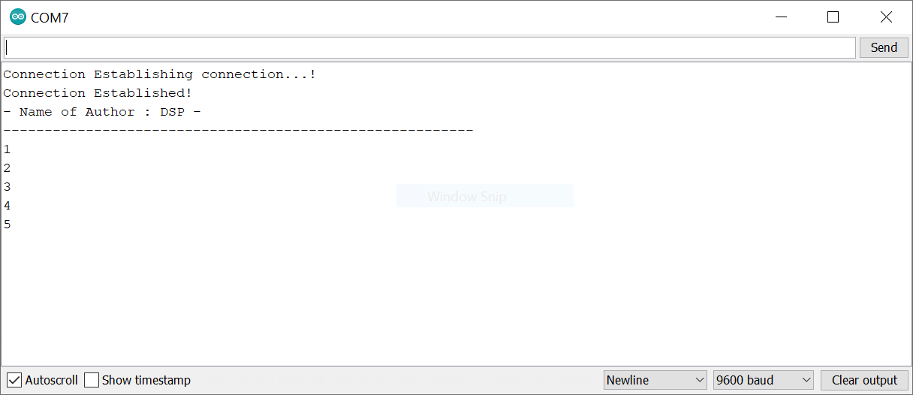Output:

Output From Dwaidh Terminal